Geometry: Constructing and Exploring space

Problem 1 Building with Side Views

Start the applet "Building with Side Views" by double clicking on nabouwenaanzichten_en.exe
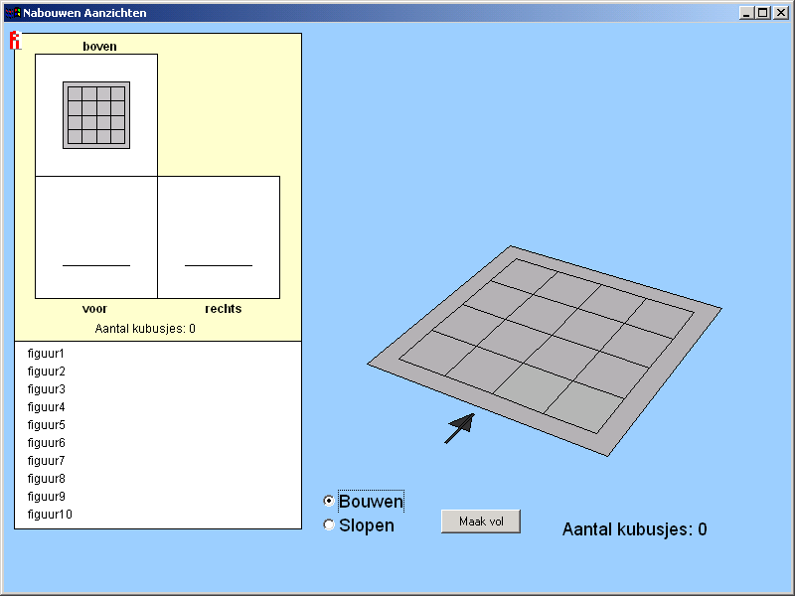
Choose one of the examples.
Here are the side views of the selected example.
Here you can build the exempel by clicking on the grid.

Of all the different examples, only the three side views are shown. The goal of the applet is to rebuild the presented examples so that you get the same side views.

- Choose object 1 and build it. If the building is correct, a green dot is shown.

Often, there are more buildings possible that give the same side views. The problem becomes more difficult when you have to use as few cubes as possible.

- Build object 1 with as few cubes as possible
Below the three side views you can read the minimum number of needed cubes.. E.g., for object 1, you need at least 12 cubes. If you have succeeded to use the minimum number of cubes, you get a yellow dot.
- Build object 10 with as few cubes as possible.

Problem 2 Constructing polygons in a 3D object

Start the applet "Draw Polygons" by double clicking on tekenveelvlak_en.exe.
With this applet, you can easily construct lines and planes in a 3D object.
- To construct a line, you click on the button makeline. Next you click on two points (vertices).
- To construct a plane, you click on the button makeplane. Next you click on all points of the plane in order (follow the directions of the clock), and finally once again on the first point.

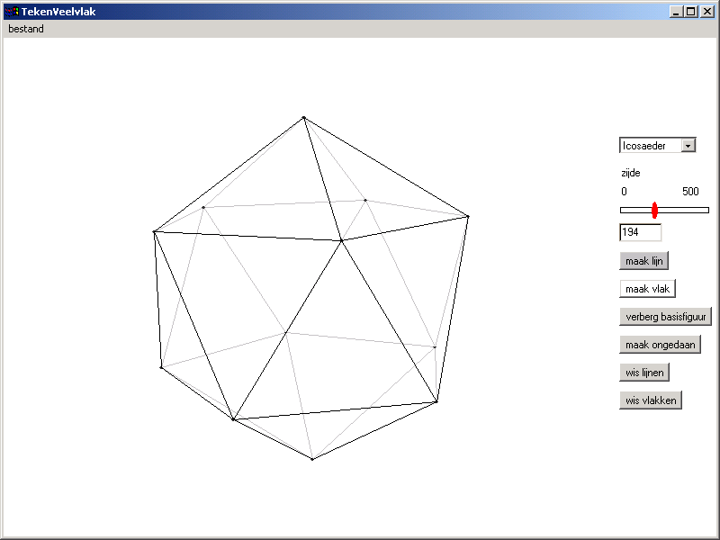
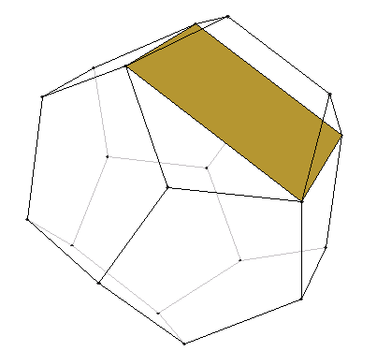
Click on the vertices (or on points of intersection) to construct kines and planes.
Choose an object as base.
Choose line or plane..
Zoom in and zoom out..
You can rotate the object by dragging it with the mouse.

- Choose the dodecahedron as base. You can use the vertices of this object to construct a cube. One of the sides of the cube is drawn in the example on the right.
Draw the other sides of the cube..

Stars
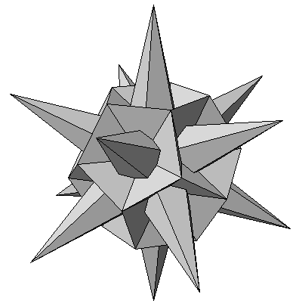In two dimensions, you can use polygons to construct stars. In the example below, you see a five-star in a pentagon.
In three dimensions, you can use polyhedra to construct 3D stars. See the examples below.

- 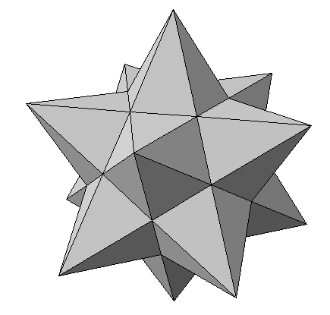Construct the "Kepler star" pictured on the right.

Problem 3 Building Blocks and Bricks

Start the applet "Walls" by double clicking on muurtjes_en.exe.
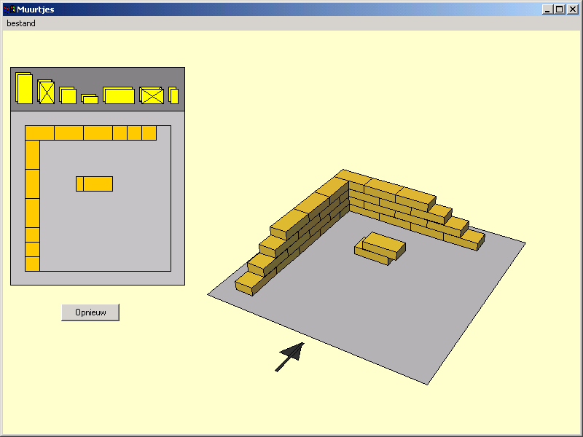
Place the bricks in the top view
A 3D-representation is shown.

There are various ways to build a wall with bricks. The way that is chosen determines how strong a wall is.
One of basic the rules is that you may never have two vertical separations between bricks on top of each other.

correct
wrong

With a “half brick wall”, it is no so hard to find a correct way to place the bricks. (in the example in the applet you see a part of a “half brick wall”).
With a “one brick wall” this becomes quite harder, especially when you want the wall to make turn of 90 degrees,

- Below, you see an example of a part of a “one brick wall”.
The construction that is used is called “standing”.
Continue the wall and make a turn of 90 degrees. Be aware of the basic rule!
(Hint: you need bricks of 3/4 lenghts)

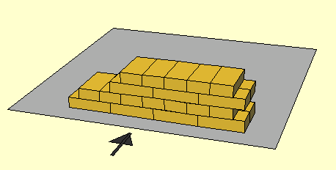

PS.
The original problems were designed for Dutch students in the context of lower vocational education. The problems become more authentic (realistic, real) when the jargon of construction workers is used. We have not worried to look up the English jargon. When you decide to use these problems, we strongly suggest to look up what the jargon is of the construction workers in your country.

